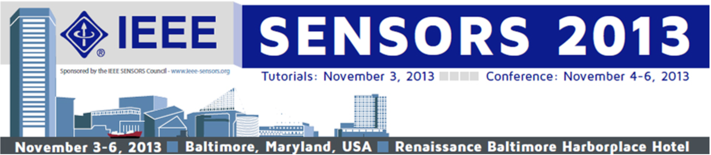

IEEE Sensors Council Student Leadership Committee

Please fill out the blanks below to sign up as a volunteer to assist the IEEE SENSORS Conference Organizing committee by serving as a technical advisor to platform presentation sessions and/or assisting at the registration counters.

First, Last name:

School/Organization:

Address:

Email address:

Arrival Date/Time in Baltimore:

As mentioned in the email you received, priority will be given to students in an engineering academic program at a university or college that has an active IEEE student branch.

Please indicate the time(s) below that you are able assist at the registration check-in counters and/or assist as a technical advisor to platform presentation sessions. You are encouraged to sign up for as many time slots as you are able.

Sunday, November 3 |  | Available (Y/N)
12:00 - 17:00 | Registration
08:30 - 10:20 | Tutorial Session
10:40 - 12:00 | Tutorial Session
13:30 - 14:50 | Tutorial Session
15:10 - 16:30 | Tutorial Session
Monday, November 4
07:00 - 17:00 | Registration
08:30 - 09:15 | Keynote
09:30 - 10:45 | Oral Session
11:15 - 12:45 | Oral Session
15:45 - 17:00 | Oral Session
Tuesday, November 5
08:00 - 08:45 | Keynote
09:00 - 10:15 | Oral Session
10:45 - 12:00 | Oral Session
15:30 - 17:00 | Oral Session
Wednesday, November 6
08:00 - 08:45 | Keynote
09:00 - 10:15 | Oral Session
14:00 - 15:15 | Oral Session
15:45 - 17:00 | Oral Session

**Please return this completed form to Chris Dyer (cdyer@conferencecatalysts.com) NO LATER THAN Monday, October 21st.

